RAJASTHAN TECHNICAL UNIVERSITY, KOTA

JAIPUR ENGINEERING COLLEGE AND RESEARCH CENTRE

**DEPARTMENT OF INFORMATION TECHNOLOY**

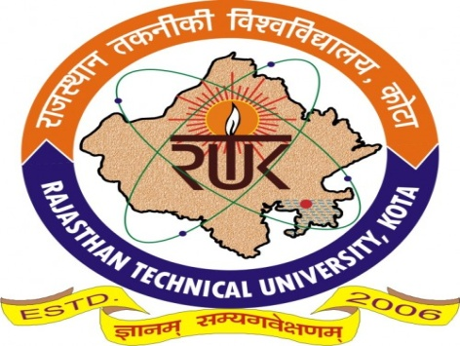

**CERTIFICATE**

*This is to certify that the work, which is being presented in the project entitled “****Real Estate CRM****“ submitted by* ***Mr. Sanchit Bhargava, Mr. Rahul Soni, Ms. Tanushri Goyal, Ms. Manisha Shekhawat*** *the students of fourth year (VIII Semester) B.Tech in Information Technology in partial fulfillment for the award of degree of Bachelor of Technology is a record of student’s work carried out and found satisfactory for submission.*

Mr. Deepanshu Soni

Salesforce Consultant

Appirio, A Wipro Compamy

|  |  |  |
| --- | --- | --- |
| Mr. Piyush Gautam | Mr. Naveen Kumar Kedia | Dr. Sunil Kumar Jangir |
| Project Guide  Assistant Professor, IT | Project Coordinator  Assistant Professor, IT | HOD, IT-JECRC  Associate Professor |